Medway 22nd Annual
CHRISTMAS PARADE
 | 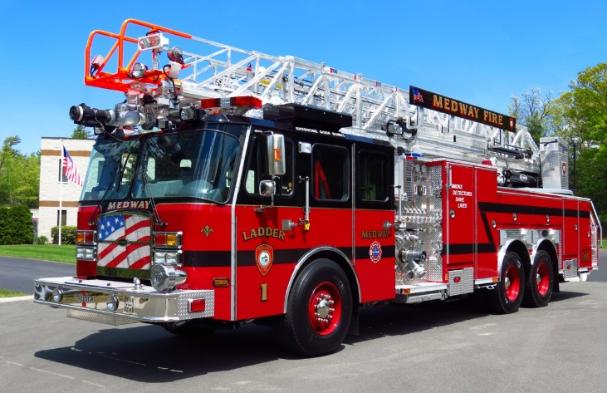 | 

HELP US LEAD SANTA’S SLEIGH!

DATE: SATURDAY NOVEMBER 29, 2014

4:30PM Sign-In & 5:30PM Parade Step Off

STAGING: 42 Broad Street - Medway, Massachusetts

ROUTE: Broad to North to Holliston to Main to Milford Streets

The Medway Fire Department and Medway Christmas Parade Committee welcome all fire departments & antique apparatus owners to join us for our 2014 Annual Christmas Parade. As a tradition here, fire apparatus from across the region are adorned with festive Christmas lights and lead the way as Santa makes his first appearance of the Season. It is a great treat for kids of all ages!
Trophies will be awarded for Newest Apparatus In Service, Oldest Apparatus In Service, Furthest Distance Traveled, Best Decorated Apparatus, Best Antique and SANTA’S BEST OF 2014 PARADE.
The parade steps off promptly at 5:30PM. Apparatus can access the staging area on Broad Street and will muster in the area of the Medway Department of Public Services Facility. Please note that this is a new staging area for 2014. Personnel will be there to assist. Following the parade, food & refreshments will be provided to any and all participants at Medway Station 1 at the intersection of Milford & Summer Streets. Please feel free to contact Lt. Brian Tracy at Medway Fire, (508)533-3211, or e-mail questions & RSVPs to medwayparade@comcast.net. Thank you!!

